Assignment 23.
- Retrieve data from purchase order header table and item table to create purchase order by inner join.
- Purchase order header table: EKKO
- Purchase order item table: EKPO
- Retrieve data from purchase order header table:
- 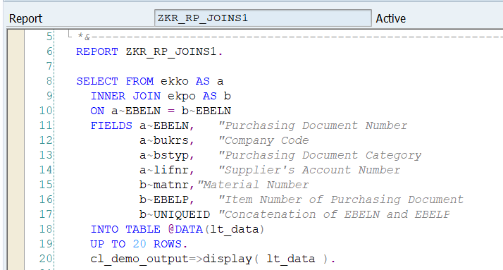
- Output:
- 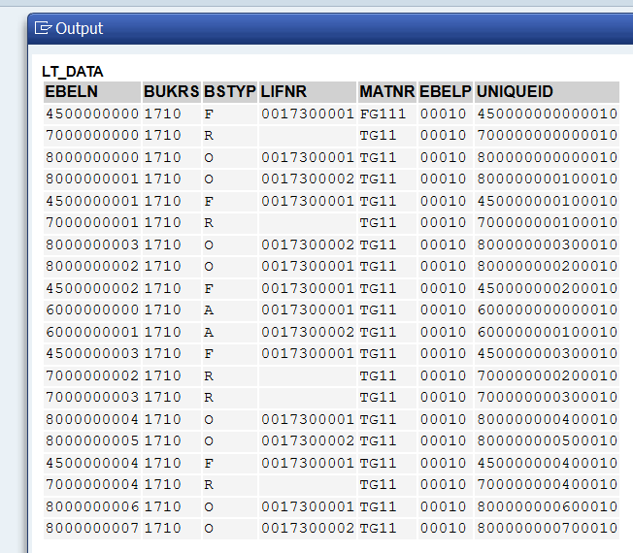
- Retrieve data from purchase order header table and item table to create purchase order by for all entries?
- Purchase order header table: EKKO
- Purchase order item table: EKPO
- 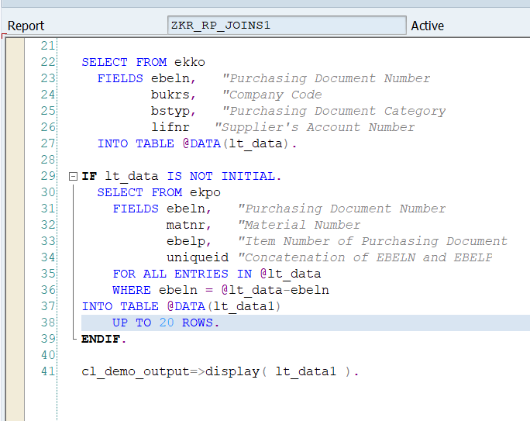
- Output:
- 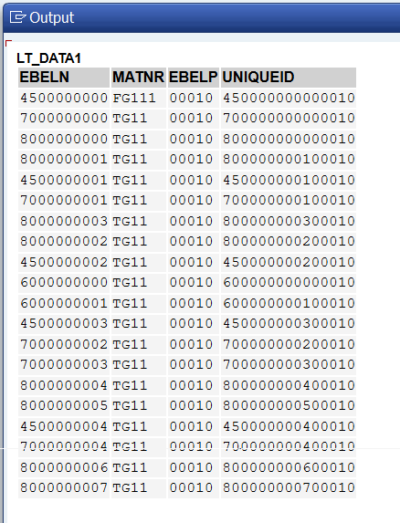
- 3. Retrieve data from purchase order header table and item table to create purchase order by parallel curser techAQ1?

- Explore on the exact difference between all of the above techniques?

